PIMAP Plus: Success Stories
- Sino-European Innovation Event of COSME PIMAP+ project: A great success of participation and outcomes: 16-17 June 2021
From 16th to 17th June 2021, ALPHA-RLH competitiveness cluster, as the coordinator of PIMAP Plus project, has organised, in cooperation with the Department of International Cooperation, Ministry of Science and Technology (China) and the Beijing Zhongguancun Overseas Science Park Co., Ltd, the Sino-European “Optoelectronics and Microwave Innovation. The event has gathered about 642.000 Chinese and European participants online, and 40 persons in presential, in Beijing.
The event was the opportunity to sign a cooperation project agreement between ALPHA-RLH and ZGC Overseas Science Park, in the frame of PIMAP+ project, and enabled the French company Amplitude to officialize a partnership with Shanghai Jiao Tong University. Further, during the event PIMAP Plus partners had to opportunity to introduce their ecosystems both from an academical as well industrial perspective showcasing their innovative projects and products. John Lopez (CNRS e CELIAL senior researcher, France) gave a short overview of the last developments on surface structuration and functionalization by laser processing, Barbara Previtali (Politecnico di Milano, Italy) gives and overview of the research and innovation in the field of laser technologies in Lombardy and Pedro Viero (Controlar, Portugal) introduced some new concepts of digitalization regarding robotics and artificial intelligence. Mr Kotek gave a brief overview of the company Evektor (Czech company) and its light sport aircrafts technologies. On 17th June, European and Chinese companies took part in a roadshow to promote their unique know-how and foster exchanges through a Q&A discussion. The roadshow started with Radarbolaget which introduced its radar technologies. Afterwards, BLM group detailed its design and digitize systems for tubes processing. Then, MGM company delivered a presentation on complex electric propulsion system designs used in fully electric aircraft. And finally, two French companies, Photonis and i2S, performed presentations about ultra-sensitive intensified cameras and Terahertz cameras for non-destructive applications.
Watch PIMAP Plus video
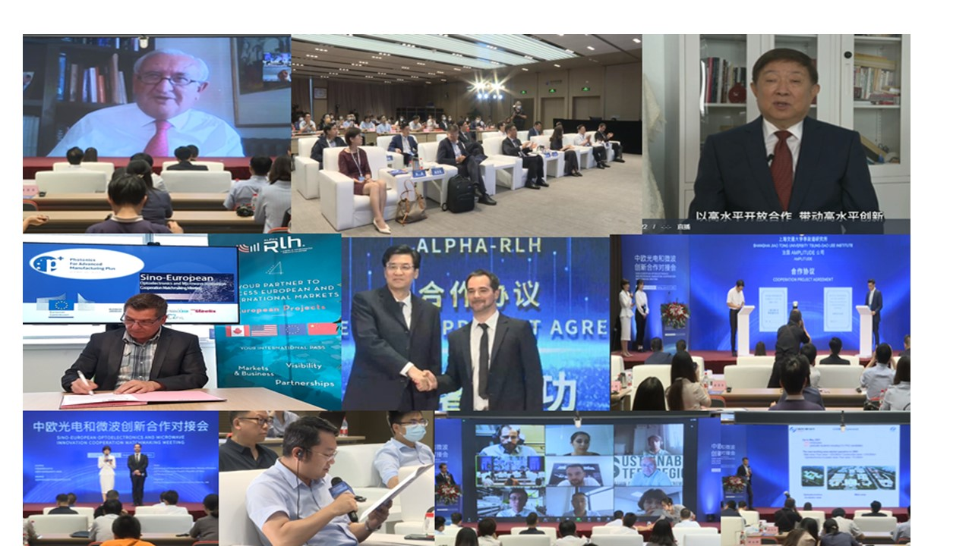

- EMO Milano: 4-9 October 2021
From 4 to 9 October 2021, PIMAP Plus consortium has supported its promising European SMEs to visit EMO MILANO 2021. Promoted by CECIMO, the European association of machine tool industries, and organized by the operational structures of UCIMU-SISTEMI PER PRODURRE, the association of Italian machine tool, robot and automation manufacturers, EMO MILANO 2021 recorded more than 60,000 visitors from 91 countries. During the event, PIMAP Plus consortium has organised a visit of the most interesting companies dealing with laser technologies that were exhibiting in EMO 2021: as a result, the consortium had the opportunity to increase and enlarge its networking sharing at the same time the opportunities related to the project. In particular, PIMAP Plus partnership had the opportunity to meet some relevant players belonging to the AFIL – who has supported the visit - ecosystem such as UCIMU and Prima Additive.
Find more with this video: https://www.youtube.com/watch?v=3jLkhcHRbvk

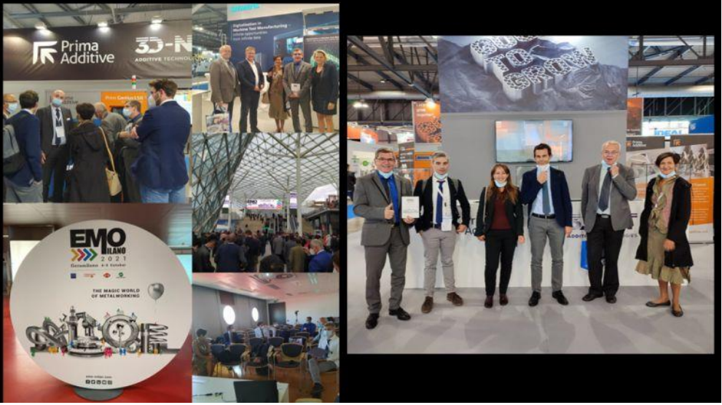

- EMAF Porto: 2-3 December 2021
PIMAP Plus consortium has organised from 2 to 3 December 2021 the visit at EMAF 2021, the international fair of machines, equipment and services for the industry that has been held in Porto, Portugal. During the visit, PIMAP Plus partnership had the opportunity to meet some members of the Produtech cluster introducing them their activities and find some potential synergies among the different ecosystems.
Further, PIMAP Plus partnership had the occasion to visit Inegi and Inesctec, two research and innovation labs in liaison with other industrial stakeholders coming from the EU project Galactica and the EIT Manufacturing promoting the synergies with these two relevant initiatives. On December 3rd, the partners attended a Forum Produtech – EIT Manufacturing – Produtech SIF. During this session, PIMAP+ project and roadmap was presented by Isabelle Tovena Pecault and Alithéa Lafaye from ALPHA-RLH.
Find more with this video: https://www.linkedin.com/posts/PIMAP-plus_canada-usa-export-activity-6873969241972854784-0rnE/
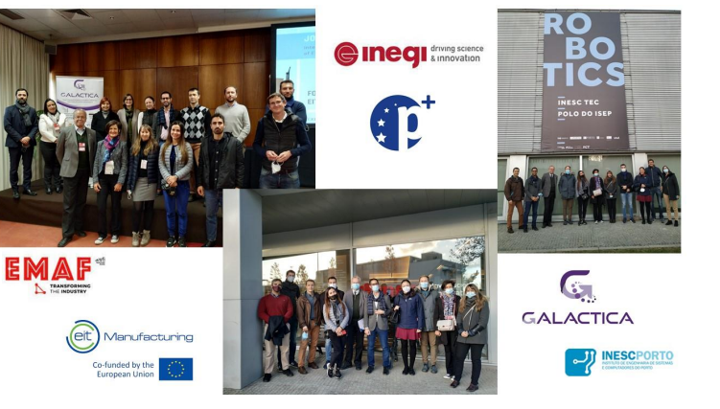

- Business Mission in Canada and MoU with Rezoway and Optonique
From 6 to 8 April 2022, PIMAP Plus consortium has carried out an international business mission in Canada (Montréal, Quebec). The mission was a success!
Seven companies belonging to the ecosystem of the six european cluster belonging to the PIMAP Plus partnership was directly supported through a three-day program of B2B meetings, customised workshop, networking events with canadian and european participants and visit of R&D centers. During the first day, each company had the opportunity to present their innovative products and their research interest related to photonics and laser technologies. Several applications were shown, from Automatic Test Equipment, and innovative X-ray imaging systems to new promising laser welding and cutting methodology able to the geometry and power distribution of the laser beam. During the other days, PIMAP Plus delegation has meet Optonique - Pôle en optique-photonique du Québec - and Rézoway allowing to better understand the canadian market and research and innovation ecosystem.
Indeed, the mission was co-organized in synergy with the local partners Optonique and Rézoway. PIMAP Plus consortium has signed a Memorandum of Understanding with them. Rezoway is a business support company in Canada who have worked with the PIMAP Plus partners to develop a personalized support program to SMEs willing to establish a presence and enter the canadian market. After the organisation of a webinar in November, Rezoway and PIMAP+ partners had the opportunity to meet during the mission.
Similarly. PIMAP+ consortium has signed a Memorandum of Understanding with Optonique, a canadian cluster that promotes Quebec's photonics sector around common goals of innovation, growth and competitiveness. This agreement aims at supporting the collaboration through a support to mutual business missions, intensification of regular exchanges and promotion of the respective ecosystems.
In terms of achievements for the SMEs, Canada’s mission has allowed to achieve overall some outstanding results: 44 total relevant contacts, 21 new potential customers, 18 new potential partners, 14 potential contracts to be signed and 18 post-mission meetings planned.
Find more reading the interviewed released by GFM, an italian company participated to the business mission, to the italian magazine Industria Italiana: https://www.industriaitaliana.it/gfm-selective-laser-melting-fotonica/
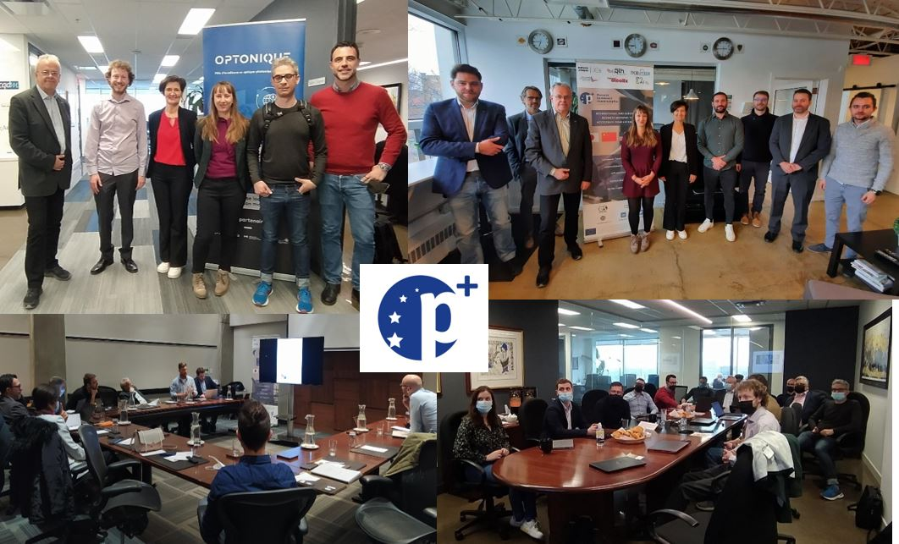
- Business Mission in USA. Aistech 2022
PIMAP Plus consortium has participated, from 16 to 18 May 2022, to AISTECH 2022 in Pittsburgh (USA), the main exhibition dedicated to the iron and steel. AISTech is the premier annual technology event of the steel industry with practically global coverage. Despite the still ongoing Corona pandemic and international conflicts with limitations for certain countries, the event gathered record participation.
Hosted by the Swedish cluster Sustainable Steel Region, PIMAP Plus was present in their booth at the exhibition together with three SME’s active in the steel value chain and focused on efficient green and sustainable steel production.
Participating SMEs were very satisfied with the arrangements and got higher than expected attention by visitors at the booth, as well as a number of new leads. Indeed, photonics represents a base for many new and improved solutions for the steel industry to meet current challenges and help forward the on-going transition to more energy efficient, environmentally friendly and digitalised steel production globally. Something that was clearly visible during the conference and in many exhibitors displays.
Visits to other photonics connected exhibitors revealed a good faith in future business opportunities, also in the light of the new project PIMAP4Sustainability, while within certain already established technologies, the competition is also quite hard (e.g., optical microscopy, position sensors, dimensional gauges). More advanced, robust and accurate sensors and instrumentation is demanded from the industry to make existing and new processes better monitored, controlled and optimized.

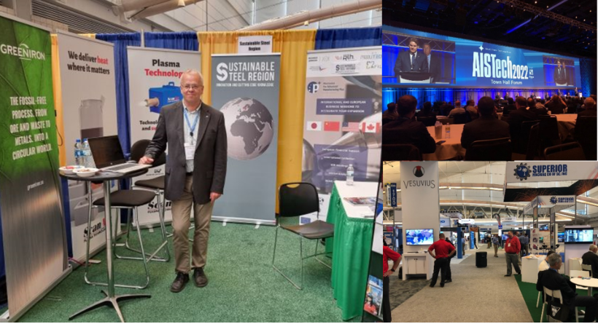

- Business Mission in Japan: Gualini Lamiere International S.p.A. success story

From 20 to 23 June 2022, PIMAP Plus consortium has carried out an international business mission in Japan (Tokyo). The activities were organized in collaboration with the French Chamber of Commerce in Japan, that supported the PIMAP Plus consortium in the agenda definition and in the organisation of several meetings paving the way for future collaborations.
Eight companies belonging to the ecosystem of the six european cluster of the PIMAP Plus partnership were directly supported through a four-day program.
The agenda included B2B meetings, business culture trainings, the visit to Panasonic Cente, Science Square Tsukuba and Jaxa Tsukuba Space Center (in Ibaraki Prefecture), as well as the participation to the Manufacturing World Japan 2022 exhibition.
The involved SMEs were Gualini Lamiere International S.p.A. (Italy), Goyalab (France), MGM Compro, TRL Space, Iguassu Software Systems, Mejzlik Propellers, Radalytica, VRgineers, Čermák Aero (all seven from Czech Republic). These companies had the opportunity to share their expertise, products, technological interests as well as to explore the Japanese market and culture.
In particular, Gualini Lamiere International S.p.A. is a Lombardy SMEs belonging to the AFIL network, being a company associated to the cluster. The company is able to offer full services for the realisation of finished products and mechanical components, placing advanced technologies and specialised know-how in the machining of sheet metals and its customer disposal.
Gualini Lamiere International S.p.A. is equipped with the main cutting, bending and welding technologies, including laser cutting and high-definition plasma cutting. In order to maintain its technological leadership and to explore the most promising opportunities, Gualini Lamiere International S.p.A has decided to join the PIMAP Plus business mission in Japan.
Mr. Marco Travella, Innovation Manager at Gualini Lamiere International, was very satisfied about his Japan experience. In this regard he commented: “We have explored many business areas. The main scope of our visit was to create an assessment on the photonics technology and the state of art of equipment. During the mission we have explored technologies and industrial approaches that we can export to Europe. Furthermore, the visit has allowed us to increase our visibility as well as our knowledge about the most recent technological and innovation trends!”
Overall, the mission was a success! Worthy of note, it was carried out just after the reopening of the Japanese borders giving the chance to European SMEs to be among the first ones to enter Japan and enjoy a privileged point of view!

